Chapter 19, Problem 30.

Find the h parameters for the networks in Fig.19.88.

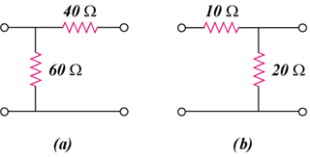

Figure 19.88
For Prob. 19.30.

